trumpet

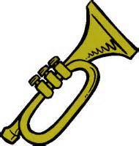

Method Book:

Traditions of Excellence, Book #1, Trumpet

Instrument Needs:

Name Tag on your instrument case
Instrument Care Kit (should include most items)
Mouthpiece 7C (Bach 7C preferred)
Al Cass Valve Oil
Slide Grease
Mouthpiece Brush
Polishing Cloth
Folding Music Stand- at home practice only

Please put your name on all instruments, method books, cleaning kits & supplies, stands, and any other item brought to the band room.

