Trombone

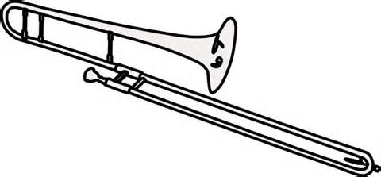

Method Book:

Traditions of Excellence, Book #1, Trombone

Instrument Needs:

Name Tag on your instrument case
Instrument Care Kit (should include most items)
Mouthpiece 12C (Bach 12C preferred)
Slide oil
Slide Grease
Cleaning Snake Brush
Mouthpiece Brush
Polishing Cloth
Folding Music Stand- at home practice only

Please put your name on all instruments, method books, cleaning kits & supplies, stands, and any other item brought to the band room.

