Percussion

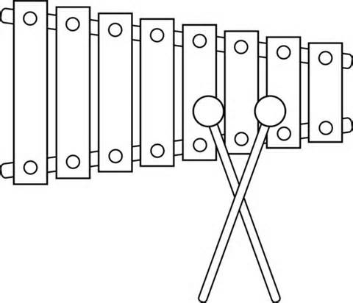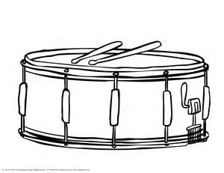

Method Book:

Traditions of Excellence, Book #1, Percussion (Drum & Bells in one book)

Instrument Needs:

Name Tag on your instrument case
Instrument Kit Including Bells & Practice Pad or Drum
Musser M24 Mallets
Vic Firth SD1 General Sticks
Stick Bag
Metronome
Folding Music Stand- at home practice only

Please put your name on all instruments, method books, sticks, mallets, stick bags, metronomes, stands, and any other item brought to the band room.

