Flute

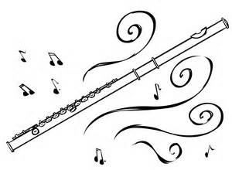

Method Book:

Traditions of Excellence, Book #1, Flute

Instrument Needs:

Name Tag on your instrument case
Instrument Care Kit (should include most of the following items)
Flute Cleaning Rod
Cloth for Cleaning Rod
Flute Polishing Cloth
Folding Music Stand- at home practice only

Please put your name on all instruments, method book, cleaning kits & supplies, stands, and any other item brought to the band room.

