Alto SaxophonE

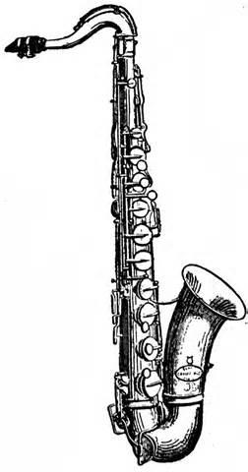

Method Book:

Traditions of Excellence, Book #1, Alto Saxophone

Instrument Needs:

Name Tag on your instrument case
Instrument Care Kit (should include most items)
Box of 10 La Voz or Rico Royal Strength 2 ½ or Medium Soft Reeds (Four working reeds every class)
Reed Case for four reeds
Cleaning Swab
Mouthpiece Brush
Cork Grease
Folding Music Stand- at home practice only

Please put your name on all instruments, method books, cleaning kits & supplies, stands, and any other item brought to the band room.

